**Title: Social Media Influence on Stock Markets**

**Sub Title: Trump tweets vs Stock markets.**

**Team Members: Rashim, Karthik, Isaac and Ervin**

**Project Description:**

Analysis of the impact of Trump’s tweets on financial markets.

**Research questions to answer:**

1. What are the sentiments of Trump’s tweets regarding certain key terms?
2. Do these sentiments have any impact on stock markets?
3. If present, how long do these impacts last?
4. Which sectors are most impacted by these tweets?
5. Is impact dependent on number of likes or retweets?

**Data sets used:**

1. Twitter API
2. Yahoo Finance CSVs
3. Alpha Vantage API

**Breakdown of tasks:**

**Part A - Twitter Data Analysis:**

1. Grab and filter at least 6 months of tweets from Trump’s twitter page using Twitter API
2. Clean the data for multiple tweets
3. Identify major key words in trump’s tweets that could be impact stock markets
4. Filter the tweets by identified keywords
5. Run sentiment analysis on filtered tweets
6. Clean the data for multiple tweets on same days so that we have a data set with unique dates
7. Filter the data on the following criteria’s. Each criterion will create a different data set for analysis vs. Stock market performance.
   1. Compound Score
   2. Negative Score
   3. Positive Score
   4. Likes
   5. Retweets

**Part B - Stock Market Analysis**

1. Identify the stock market indices and sector indices for analysis
2. Grab the pricing data for stock market indices using Alpha Vantage API
3. Grab the pricing data for major sector indices using Yahoo finance. Save the files as CSVs.
4. Calculate daily performance, next day performance and 2 day’s performance for identified stock indices.
5. Calculate daily performance and next day performance for identified sector indices.

**Part C - Merge twitter data analysis and Stock Market Analysis**

1. Merge the twitter data analysis data sets and stock market analysis in a data frame and save the file as different CSVs for final data analysis. So, we will have at least 4 merged CSVs:
   1. Compound Score + Stock market performance CSV
   2. Negative Score + Stock market performance CSV
   3. Positive Score + Stock market performance CSV
   4. Likes and Retweets + Stock market performance CSV

**Part D – Final Data Analysis**

1. Read the merged CSVs in a data frame for analysis
2. Calculate the correlation for Compound Sentiment Score vs:
   1. Stock Indices Performance
   2. Sector Indices Performance
3. Calculate the correlation for Negative Sentiment Score vs:
   1. Stock Indices Performance
   2. Sector Indices Performance
4. Calculate the correlation for Positive Sentiment Score vs:
   1. Stock Indices Performance
   2. Sector Indices Performance
5. Calculate the correlation for #likes vs:
   1. Stock Indices Performance
   2. Sector Indices Performance
6. Calculate the correlation for #Retweets vs:
   1. Stock Indices Performance
   2. Sector Indices Performance
7. Create graphs and charts using Matplotlib based on the above analysis

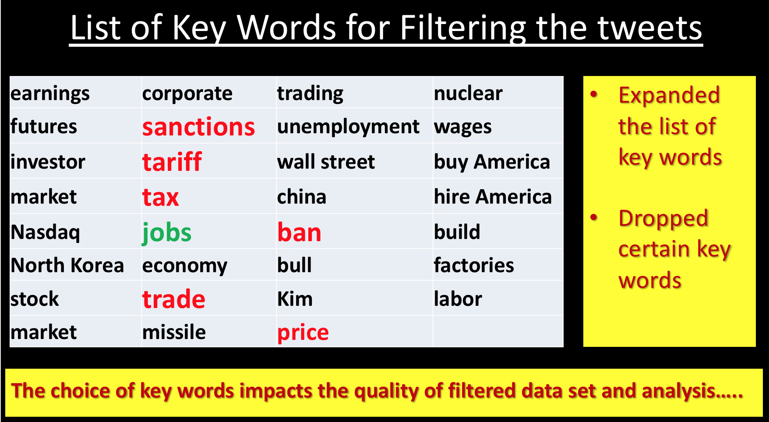

**Our Findings or Answers to the Project Questions:**

**Q.1 What are the sentiments of Trump’s tweets regarding certain key terms?**

The following dataframe gives a snapshot our sentiment analysis on Trump’s Tweets:

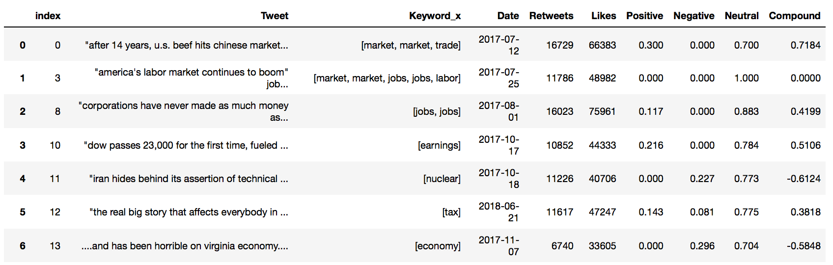

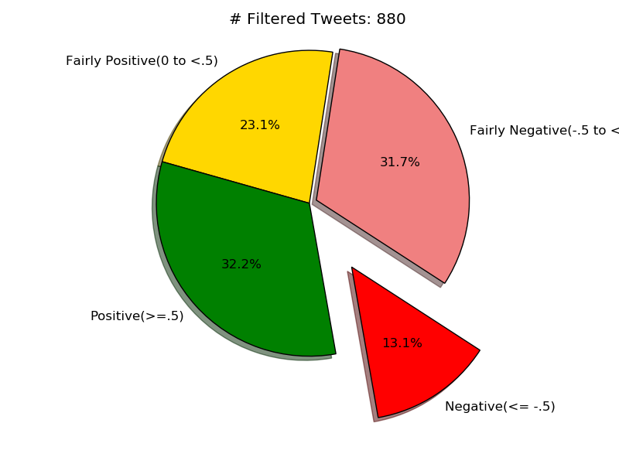

**Q.2 Do these sentiments have any impact on stock markets?**

**Q.3 If present, how long do these impacts last?**

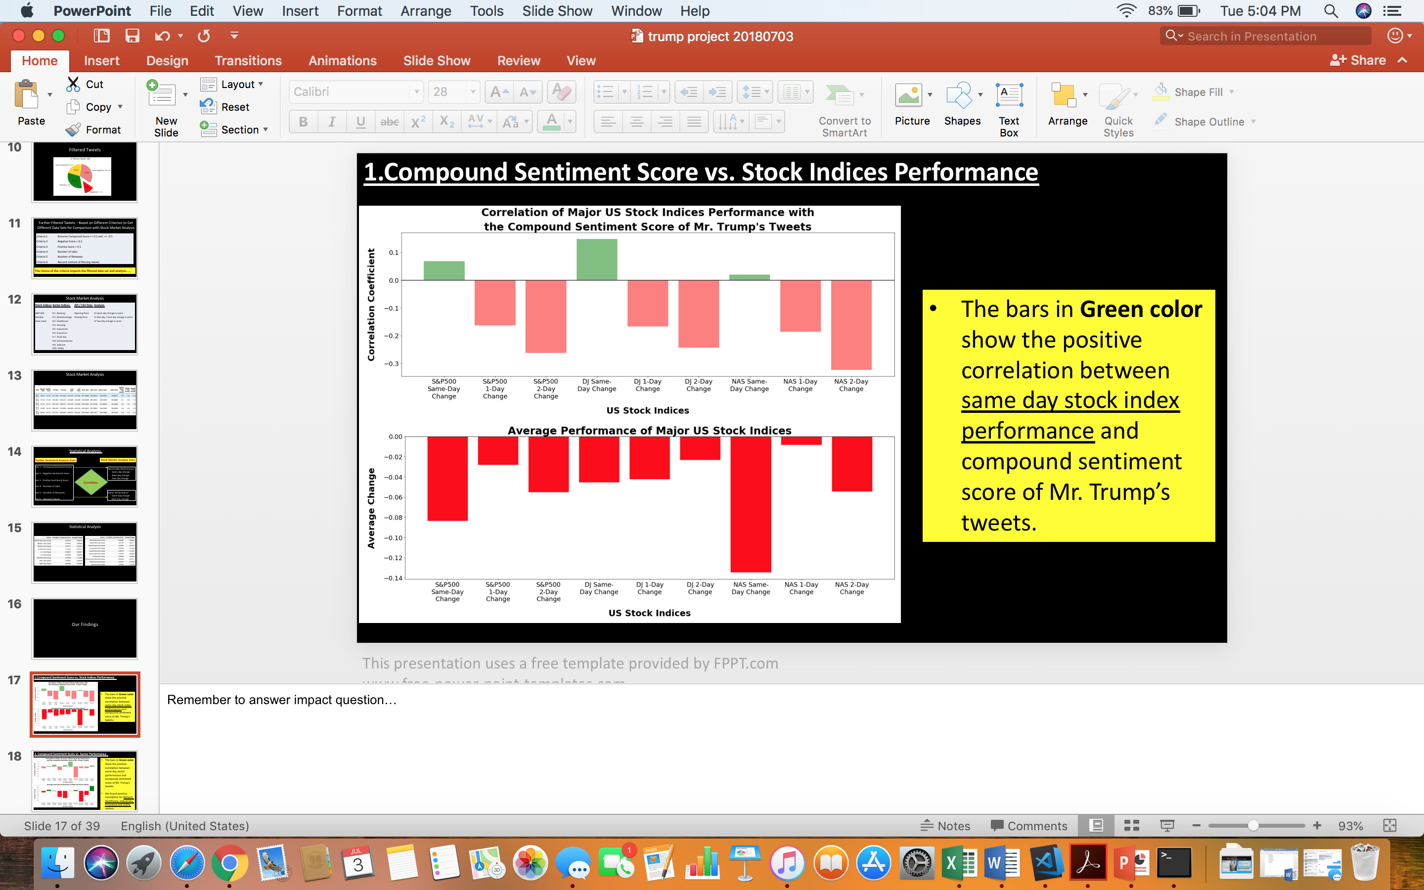

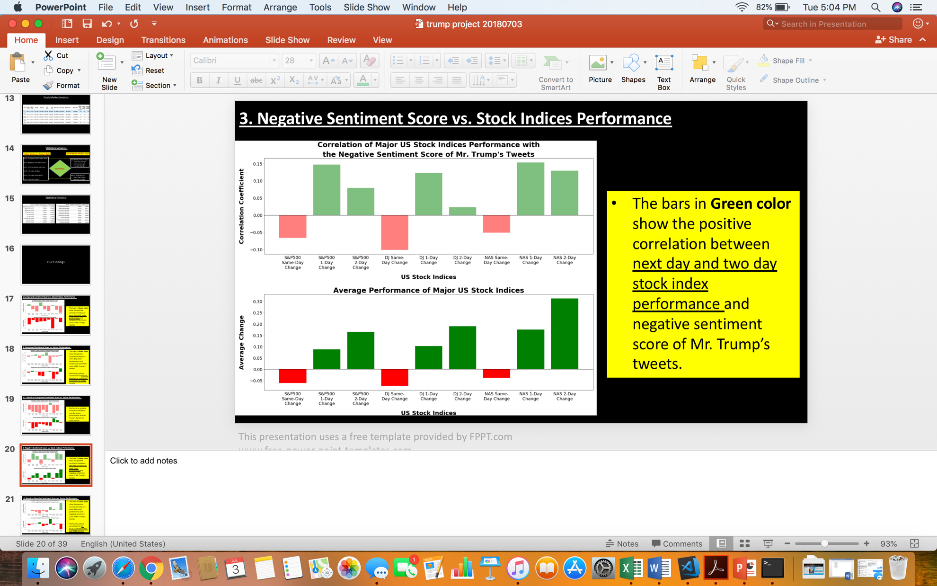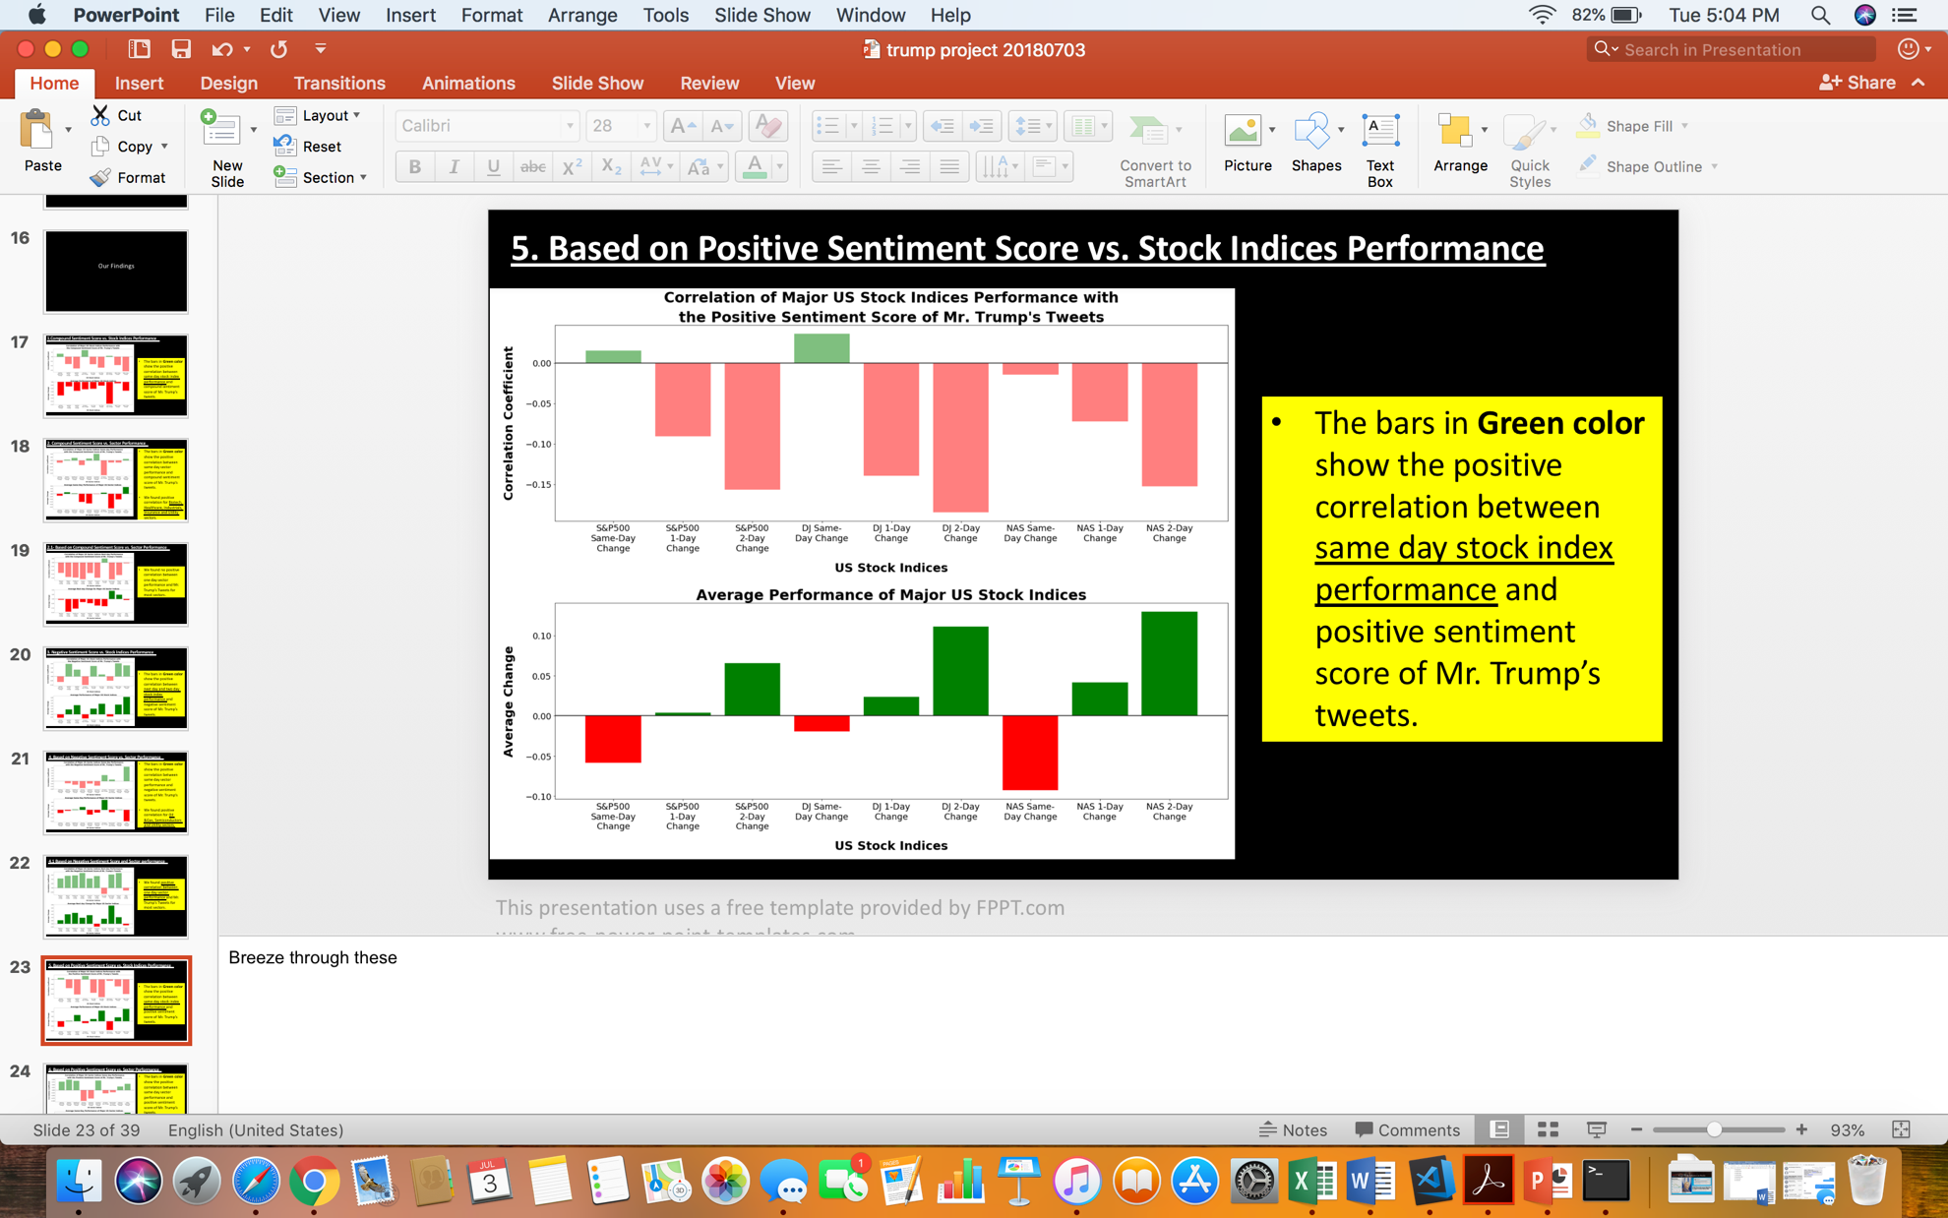

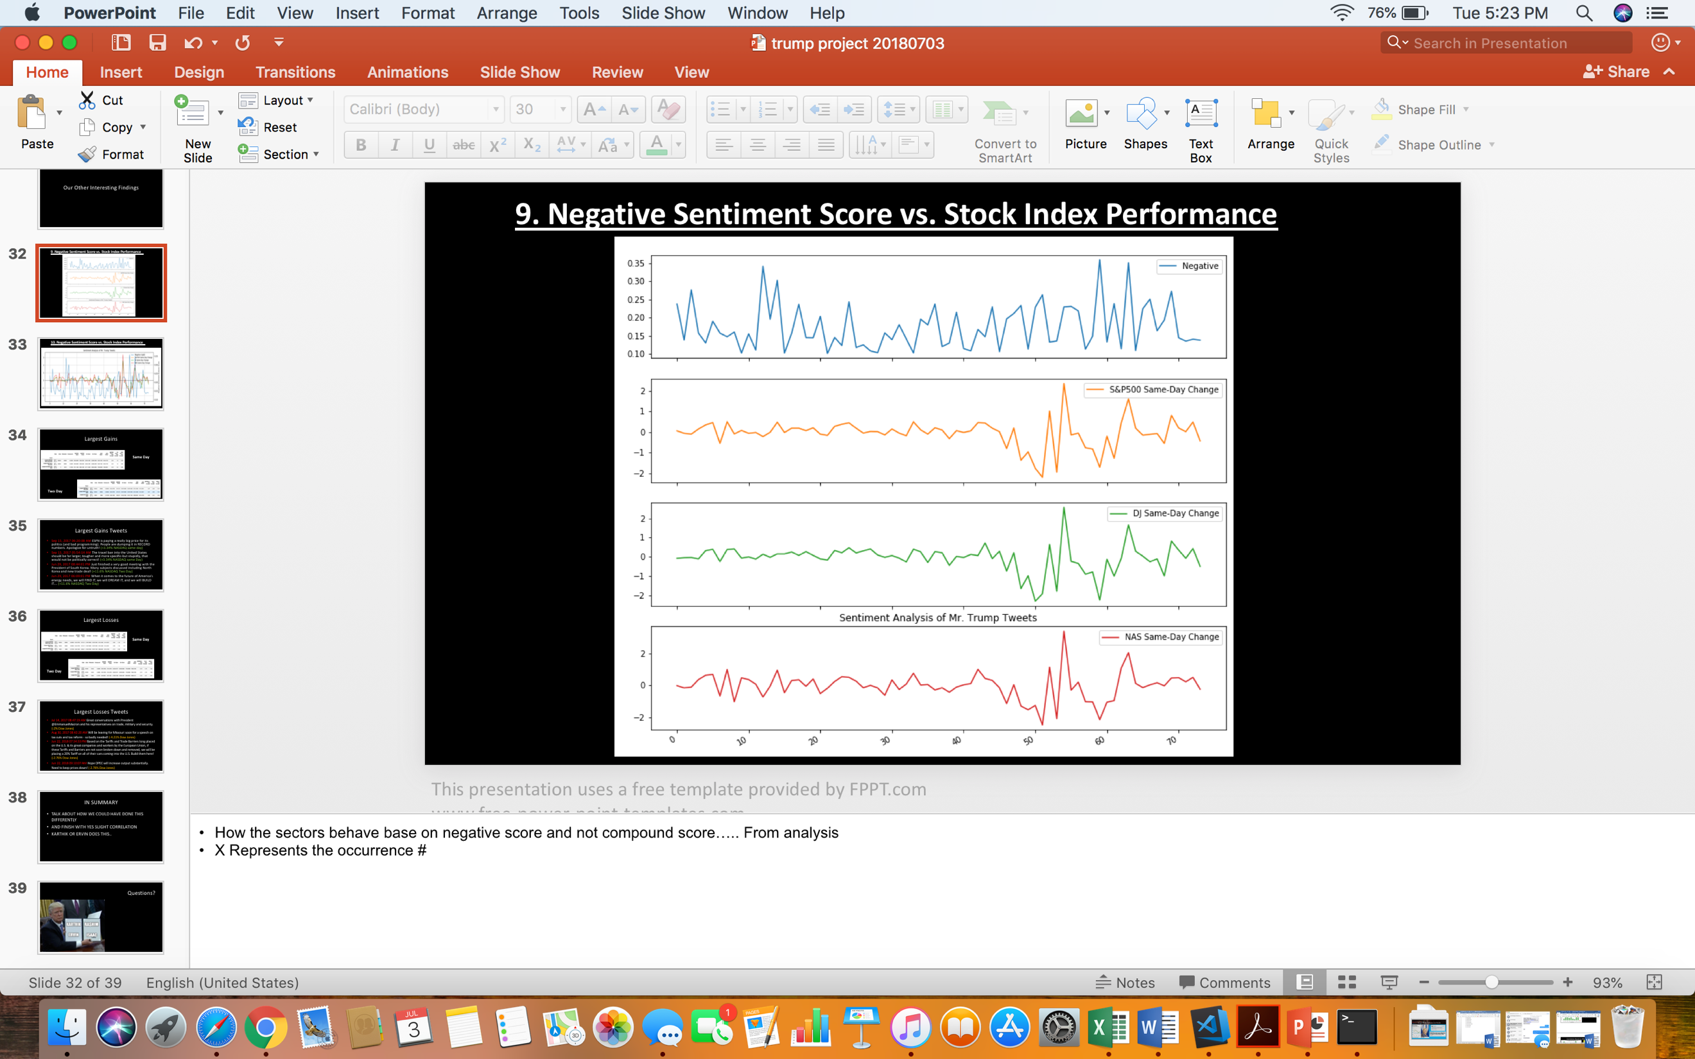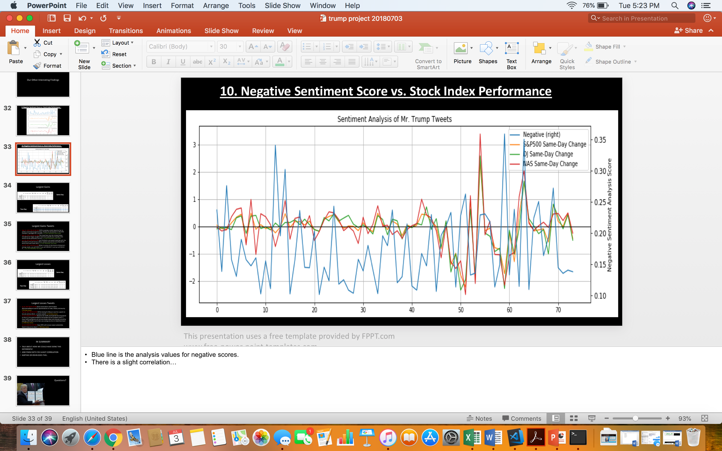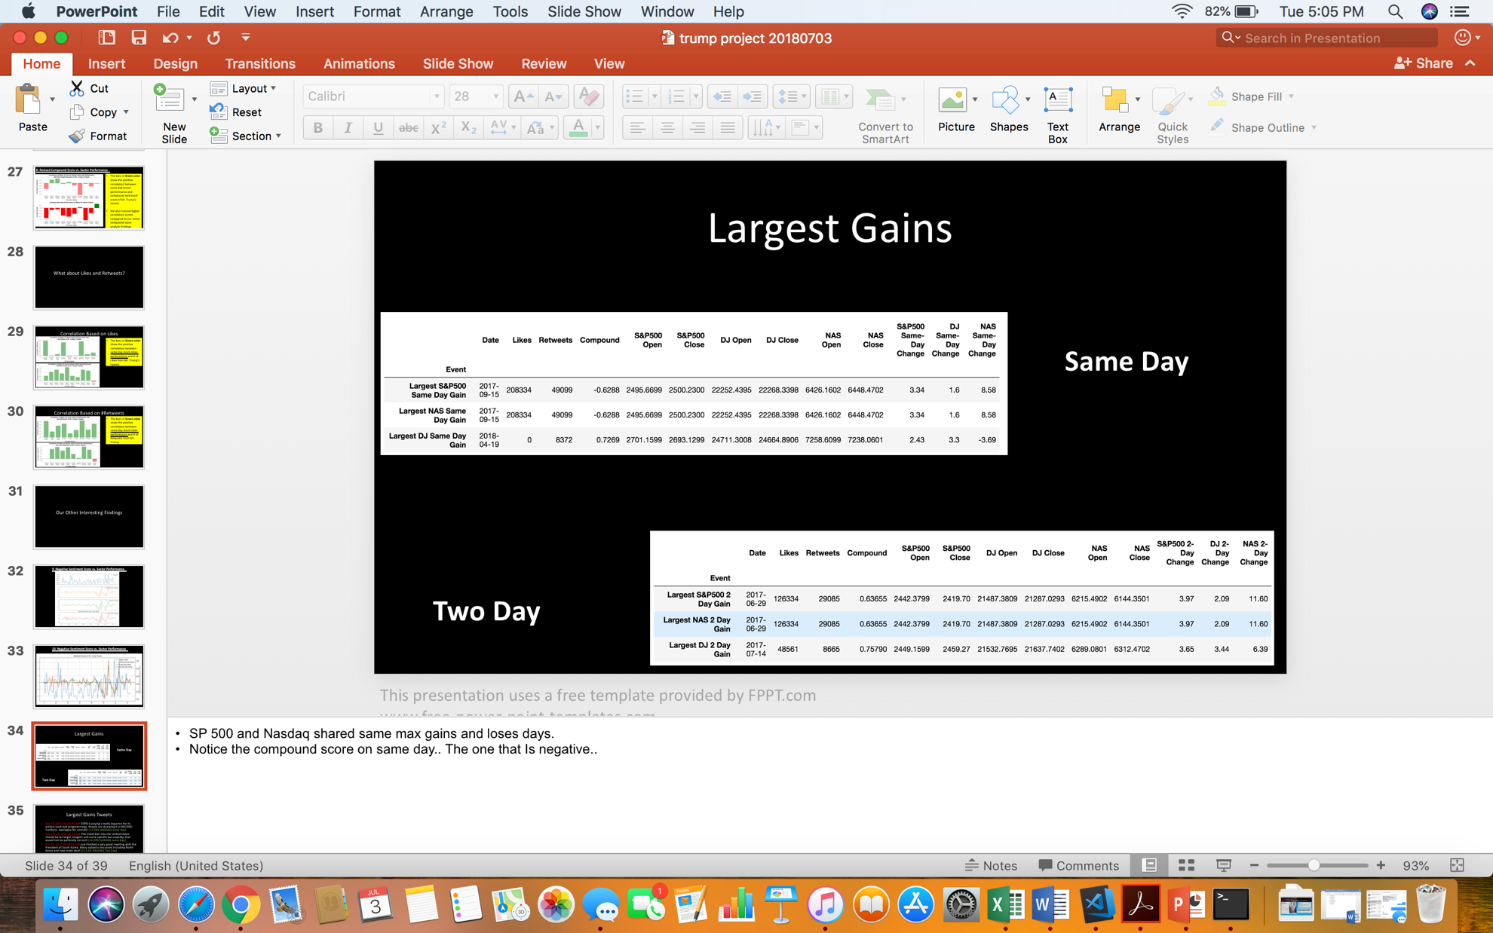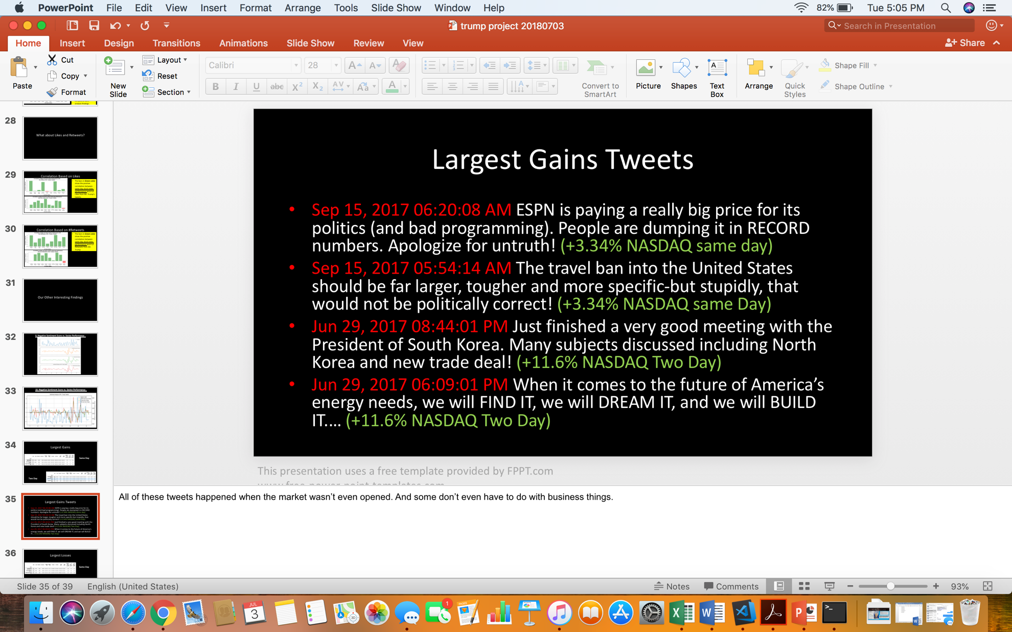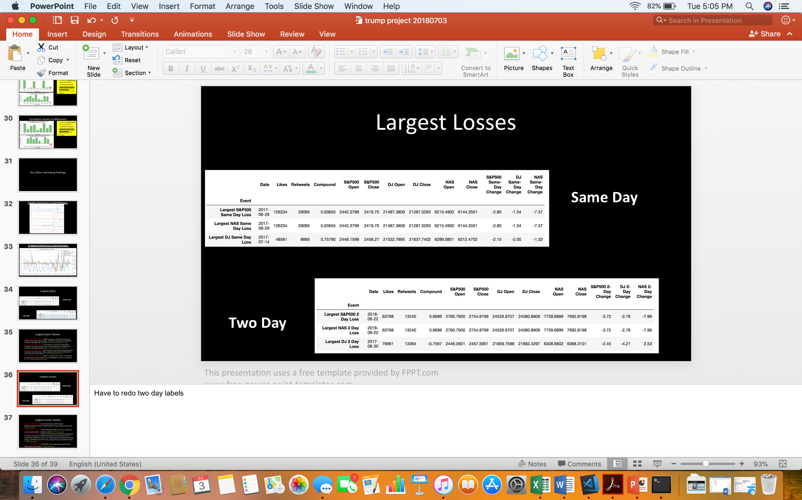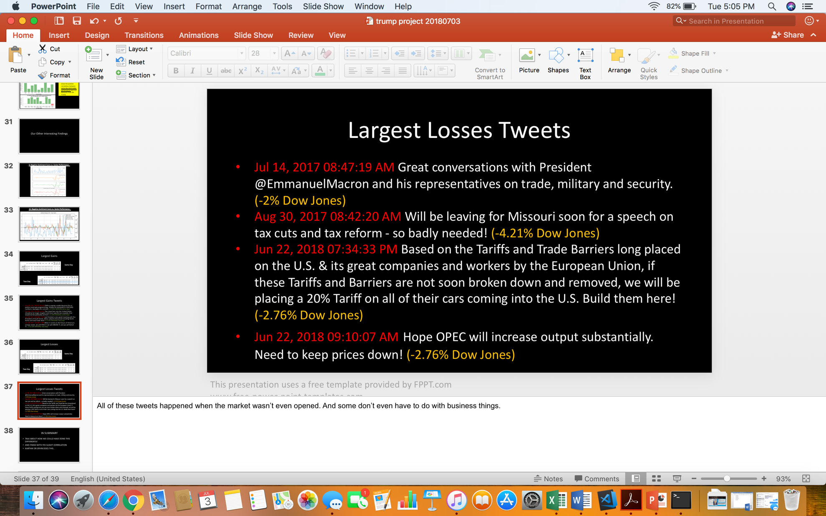

**Q.4 Which sectors are most impacted by these tweets?**

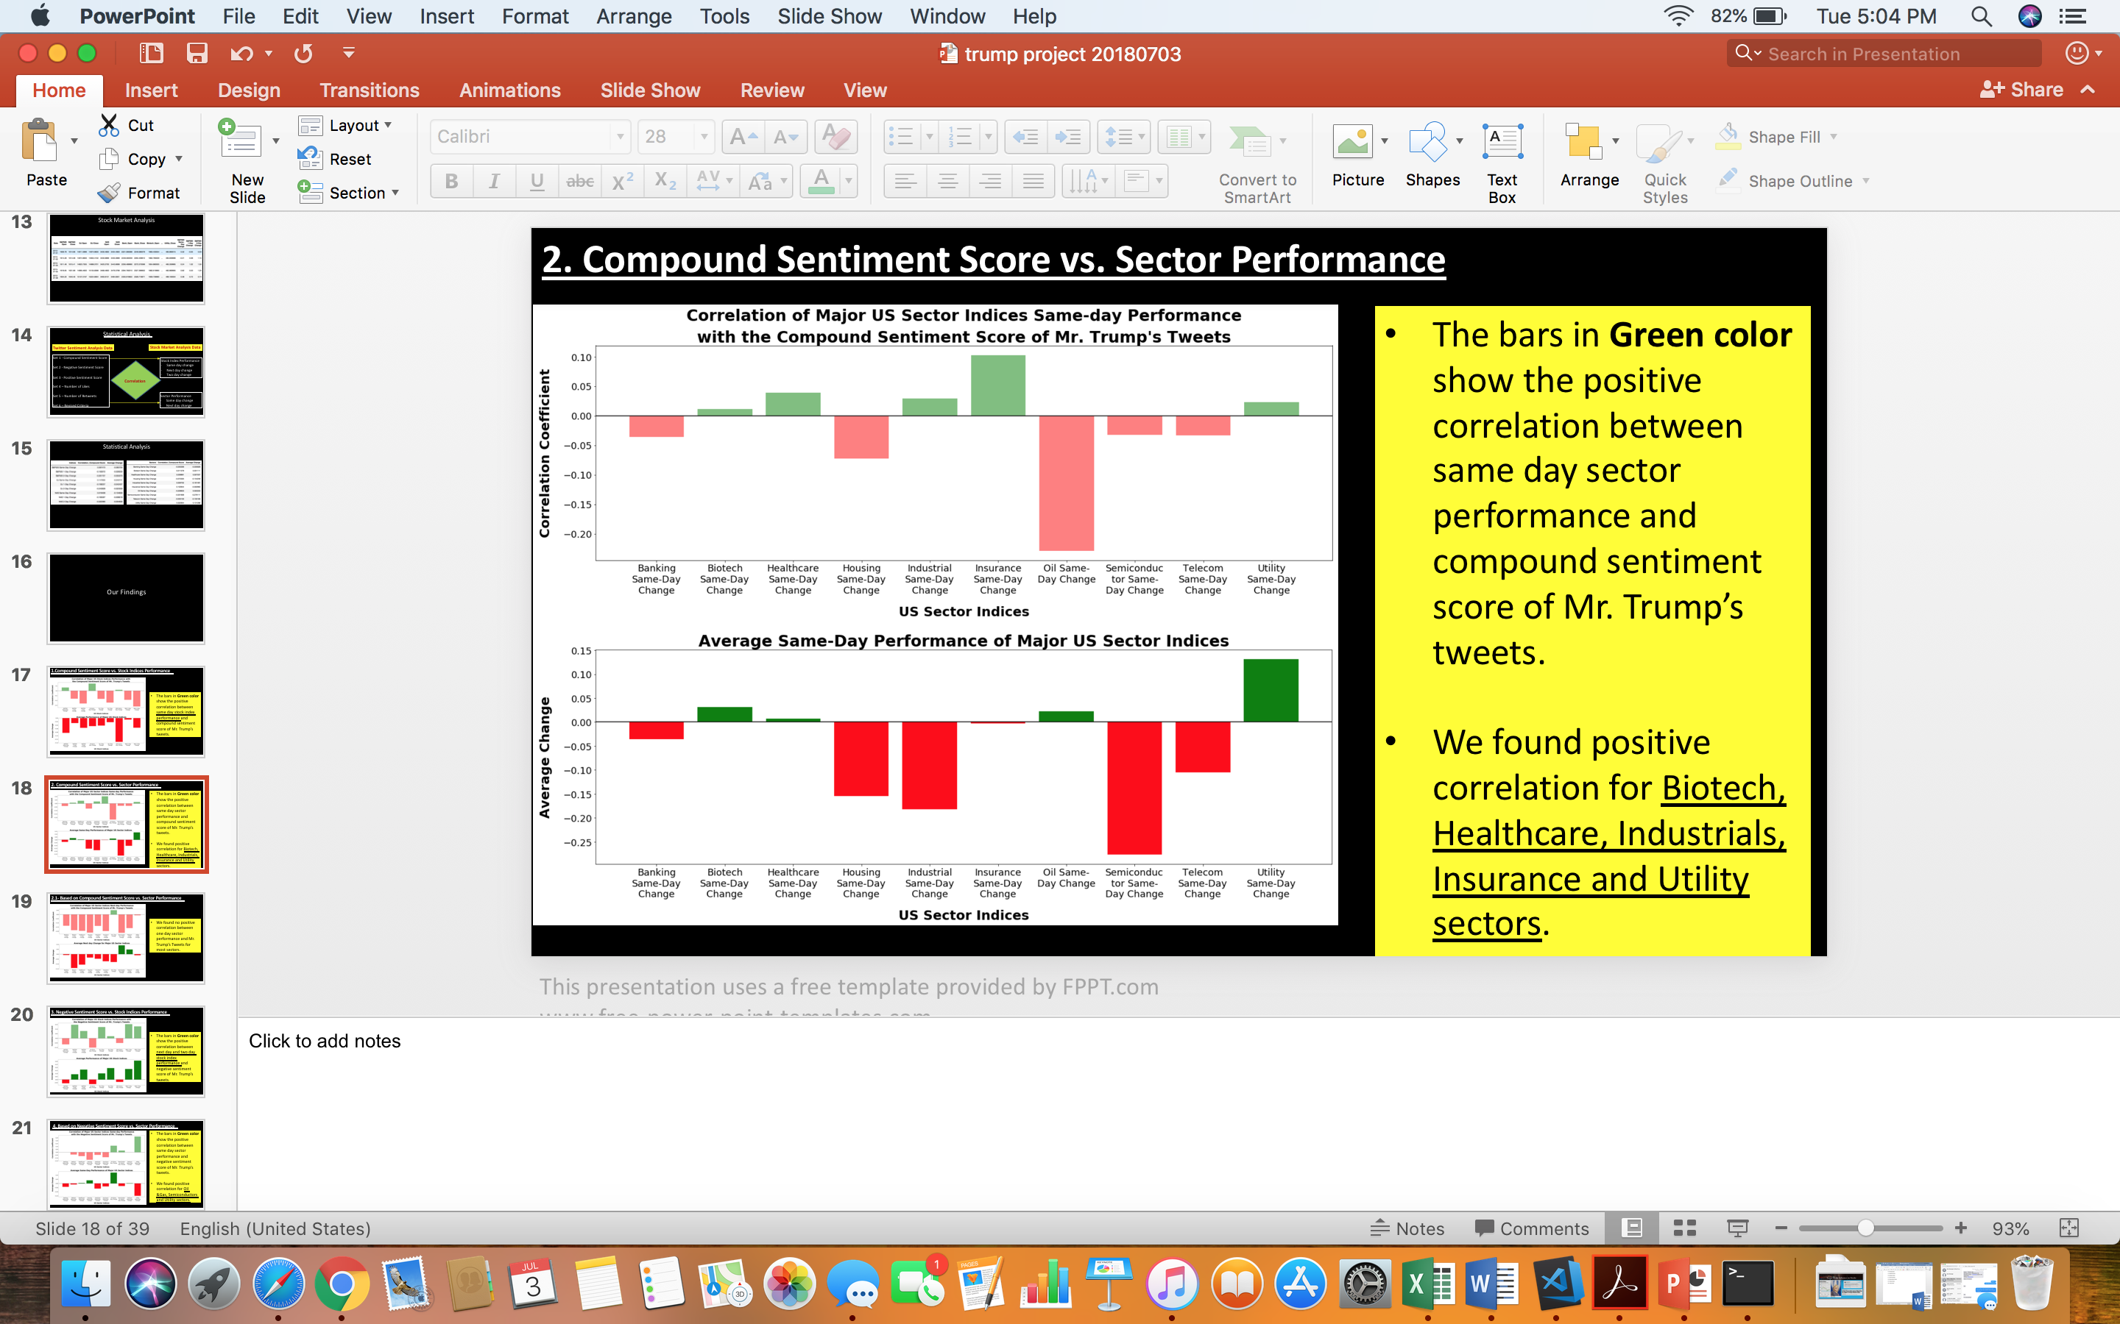

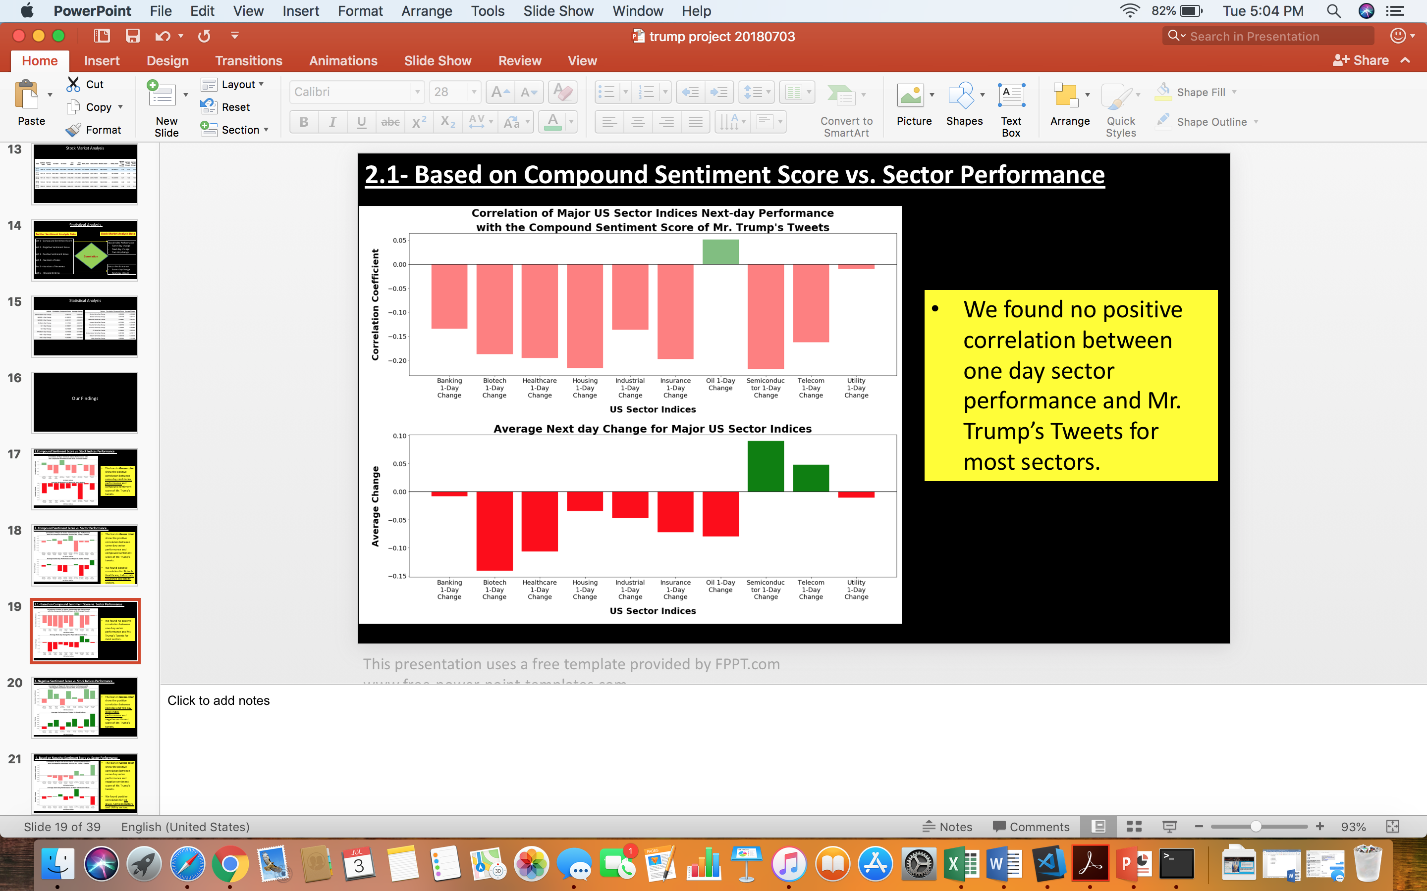

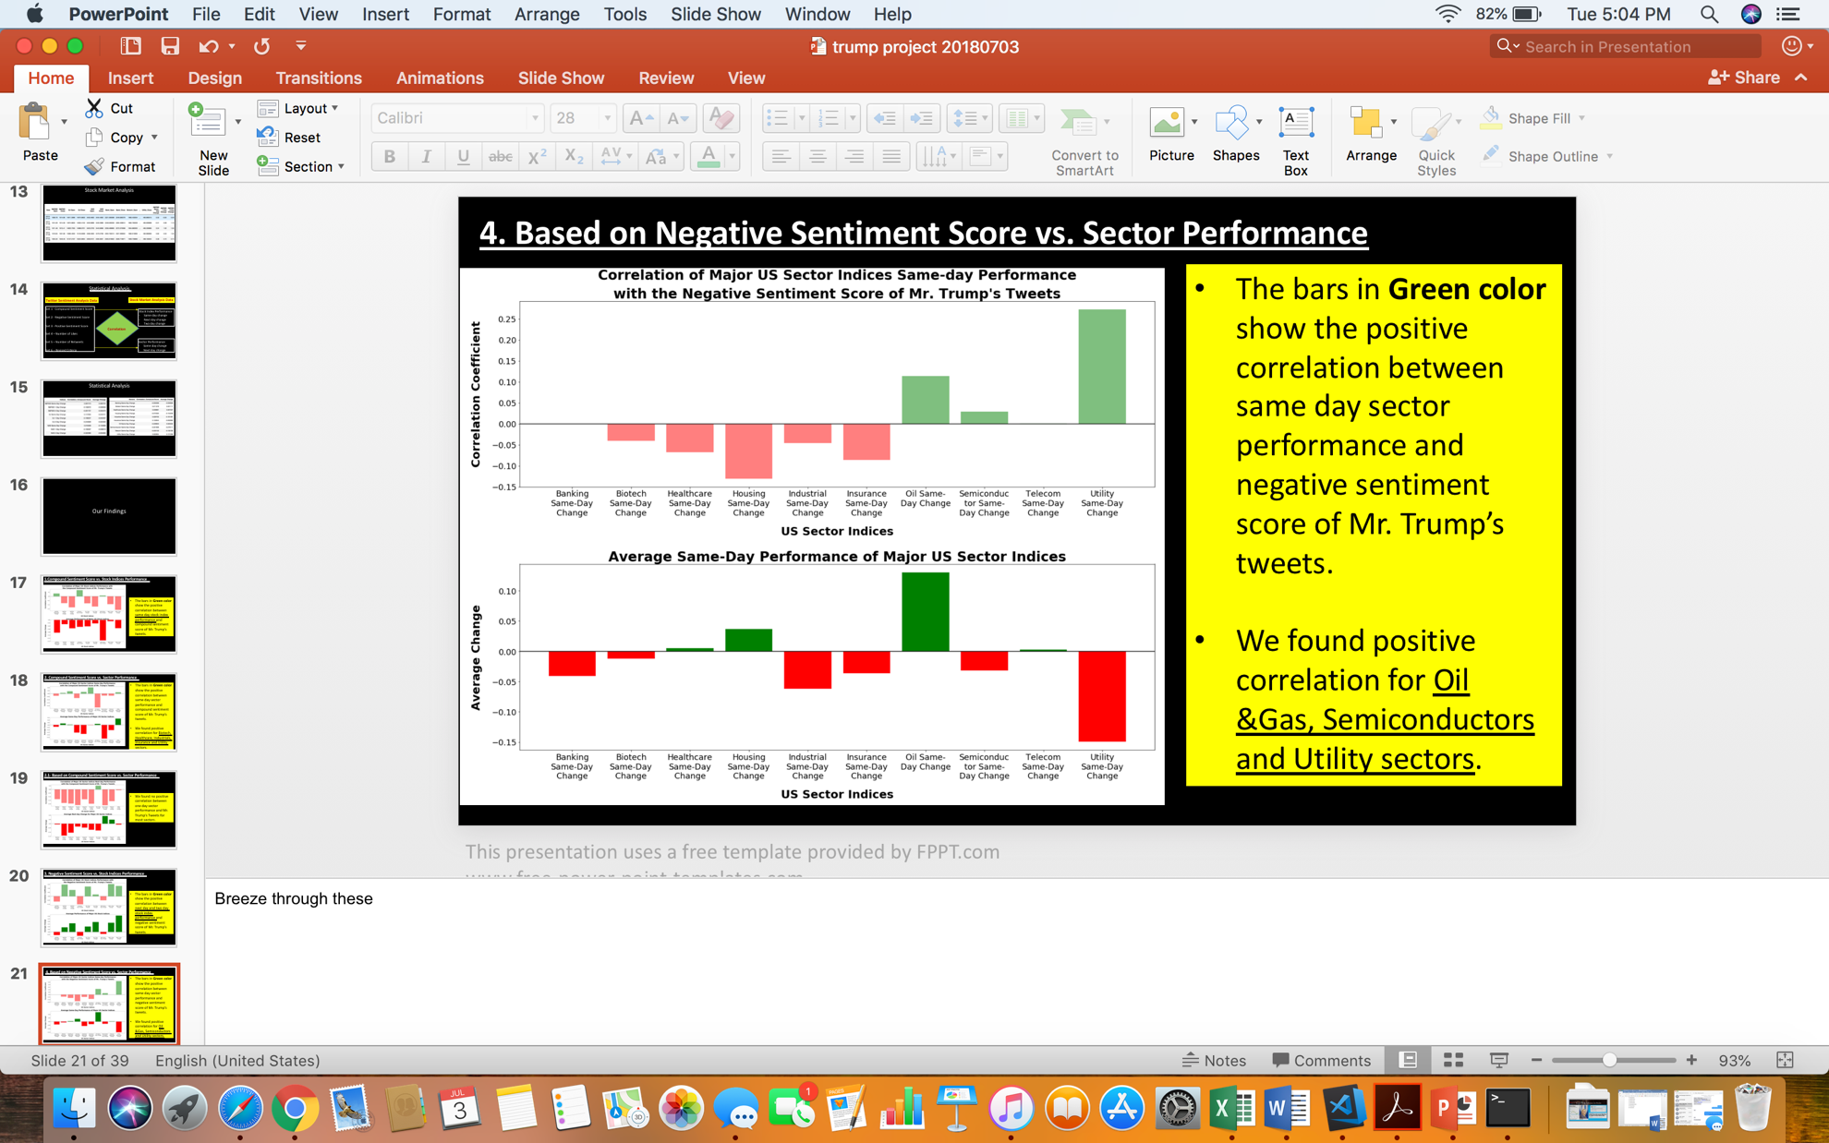

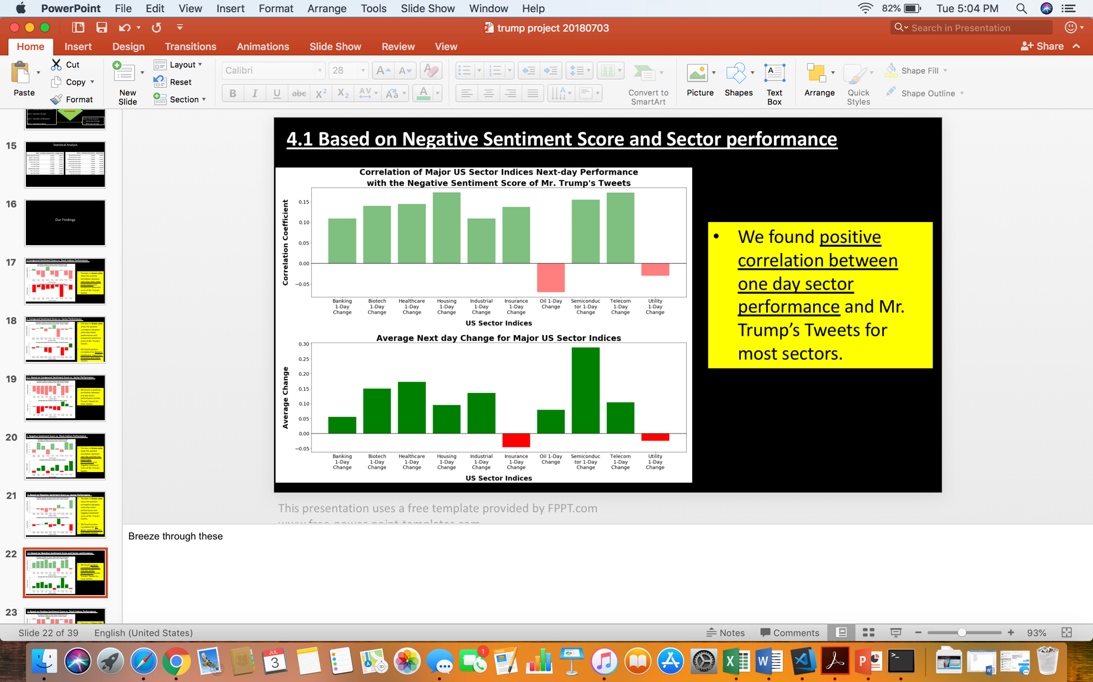

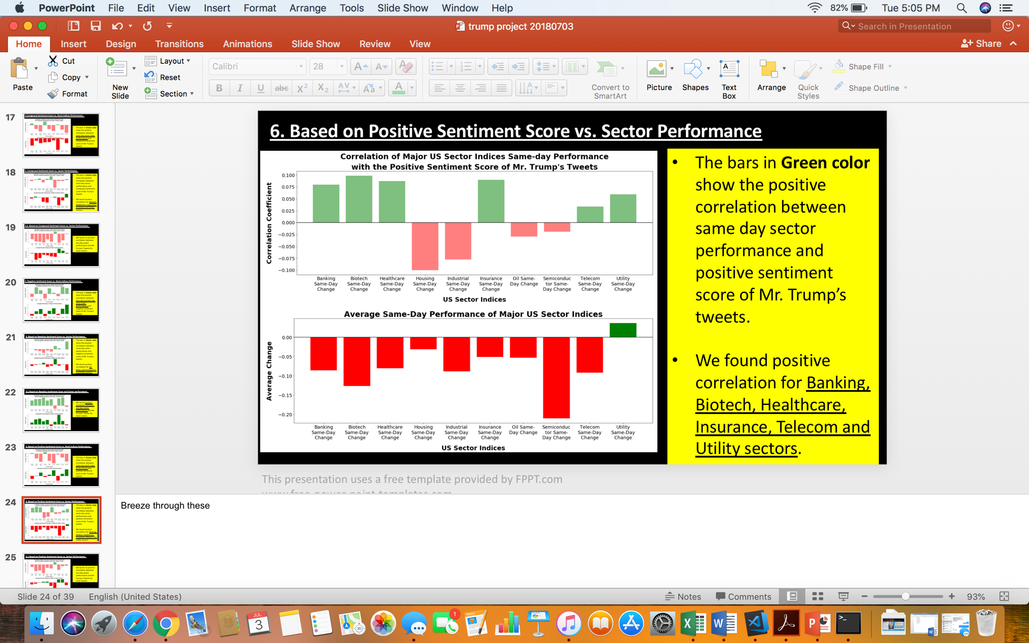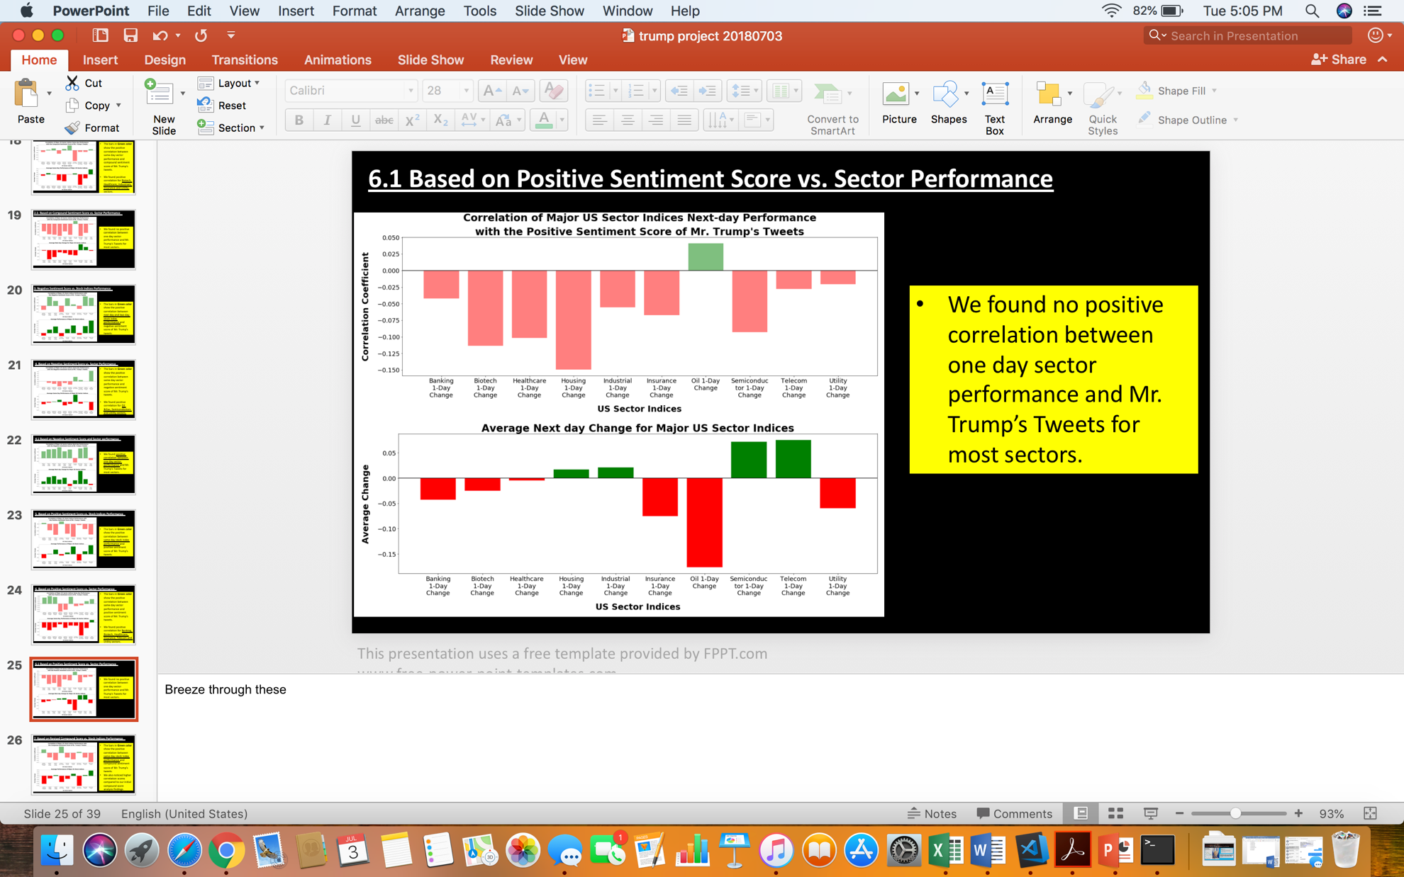

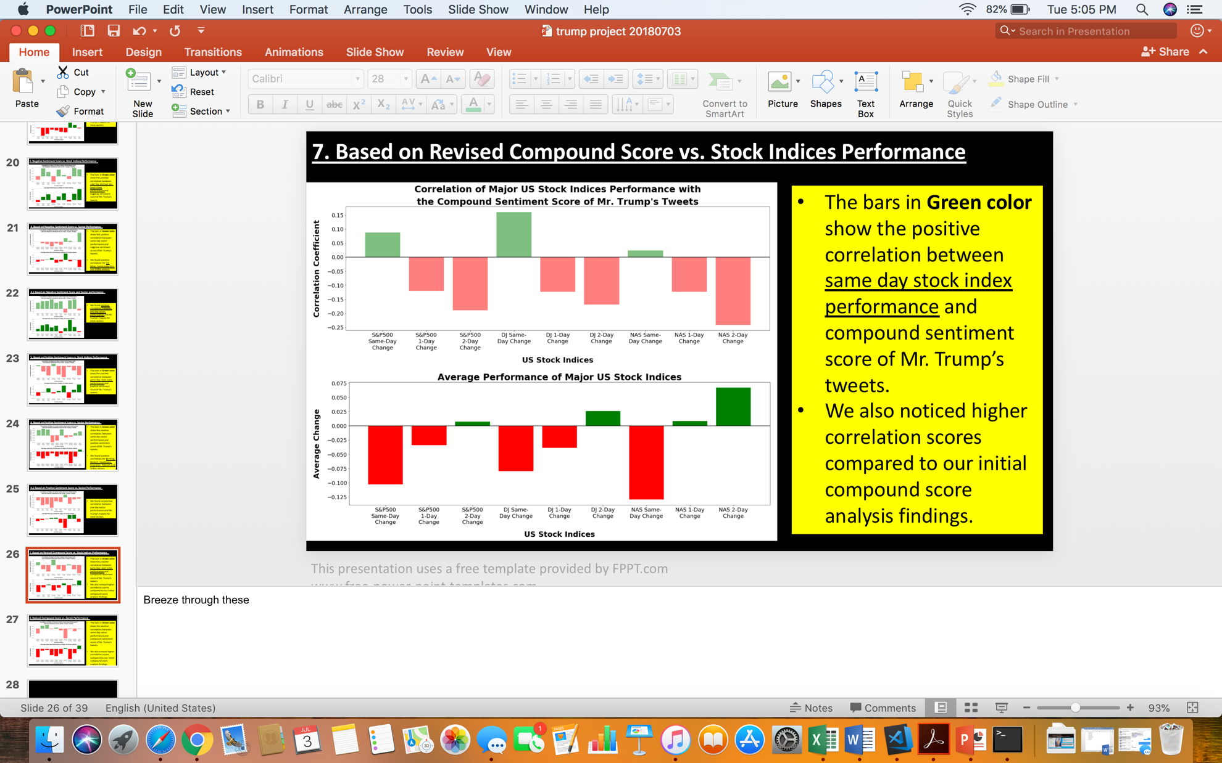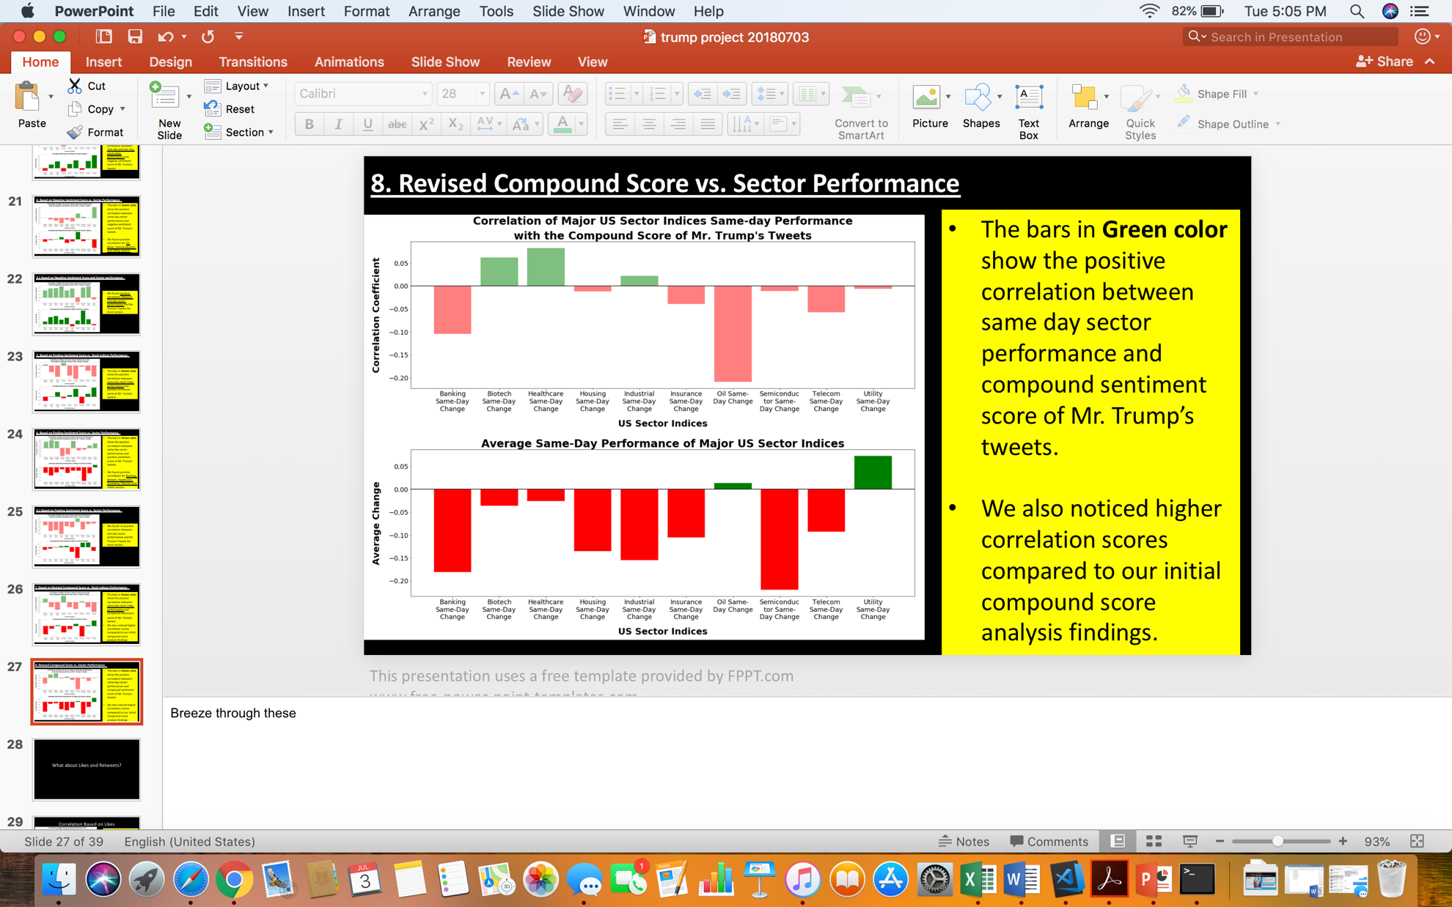

**Q.5 Is impact dependent on number of likes or retweets?**

